Beyond the Individual: How does the Work Culture and Leadership shape Workforce Mental wellbeing?

“Can leadership decisions shape the mental well-being of an entire workforce?”

Work culture and leadership play a crucial role in affecting employees’ mental health. Recent studies (Joyce, 2025) emphasize that organizational approaches have an impact beyond the individual. A supportive culture, where leaders emphasize psychological safety, offer flexible work options, and maintain open communication can help lower burnout and improve engagement. When the employees are heard they feel more comfortable sharing mental health concerns, which encourages help-seeking and builds resilience. In contrast, workplaces that have strict demands and insufficient support increase stress, leading to presenteeism, and negatively affecting marginalized groups. Strong leadership can promote well-being by building trust, inclusion, and addressing the root causes of mental health challenges rather than merely treating their symptoms.

Additionally, organizations that prioritize leadership development and embed mental health initiatives into their core policies display a long-term dedication to employee well-being. Initiatives like mentoring, regular check-ins, and collaborative decision making not only reduce stigma but build a stronger sense of belonging. When leadership approaches are guided by values of empathy and accountability, workplaces can create sustainable environments where employees feel valued and supported.

We believe mental health at work starts with culture and leadership—and we’re here to help you get it right. Together, we can turn awareness into action and make workplaces not just productive, but truly supportive.
📧 Let’s create healthier, more resilient workplaces together.
✨ Reach us at workplacewellbeingbyywp@gmail.com ✨

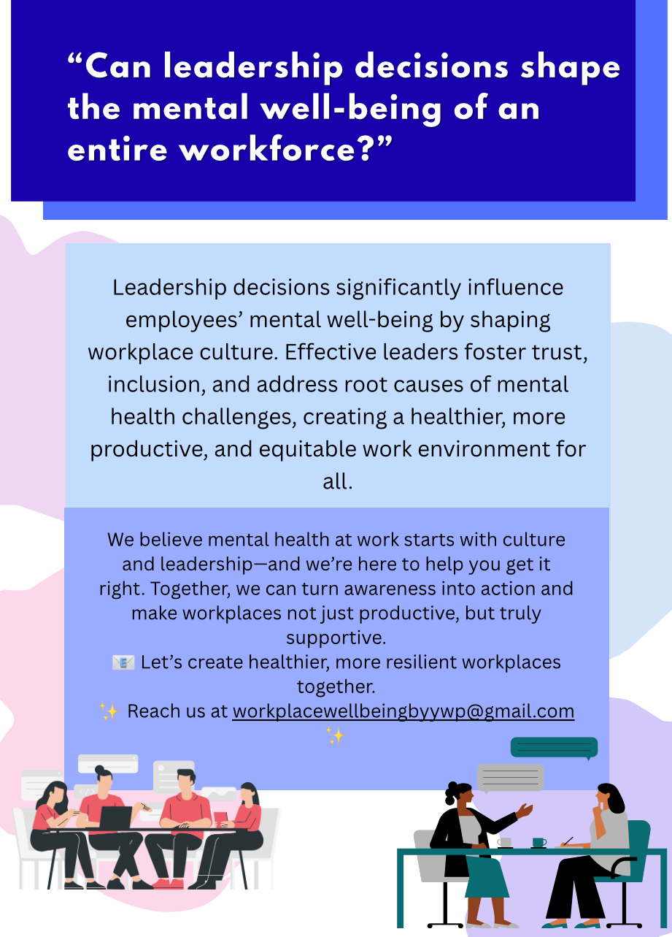

Source: https://www.reuters.com/practical-law-the-journal/transactional/mental-health-conditions-workplace-2025-05-01/

References
Joyce, R. (2025, May 1). Mental Health Conditions in the Workplace | Practical Law The Journal. Reuters. Retrieved September 16, 2025, from https://www.reuters.com/practical-law-the-journal/transactional/mental-health-conditions-workplace-2025-05-01/

